**Aim:** Simulate Discrete Time Sequences.

* **Write A Python Program to Generate the Given Signals and Plot them using Numpy and Matplotlib.**

1. Write a Python Programm To Plot Unit Impulse Signal.

**Programm:-**

import matplotlib.pyplot as plt

import numpy as np

def unit_impulse(*length*, *position*):

    signal = np.zeros(length)

    signal[position] = 1

    return signal

*# Parameters*

start = -10  *# Start value of the x-axis range*

stop = 10  *# Stop value of the x-axis range*

step = 1  *# Step size*

*# Generate x-axis values*

x = np.arange(start, stop+step, step)

*# Generate unit impulse signal*

impulse_signal = unit_impulse(len(x), abs(start)//step)

*# Plot the signal*

plt.stem(x, impulse_signal)

plt.xlabel('Time')

plt.ylabel('Amplitude')

plt.title('Unit Impulse Signal')

plt.grid(True)

plt.show()

**Output:-**

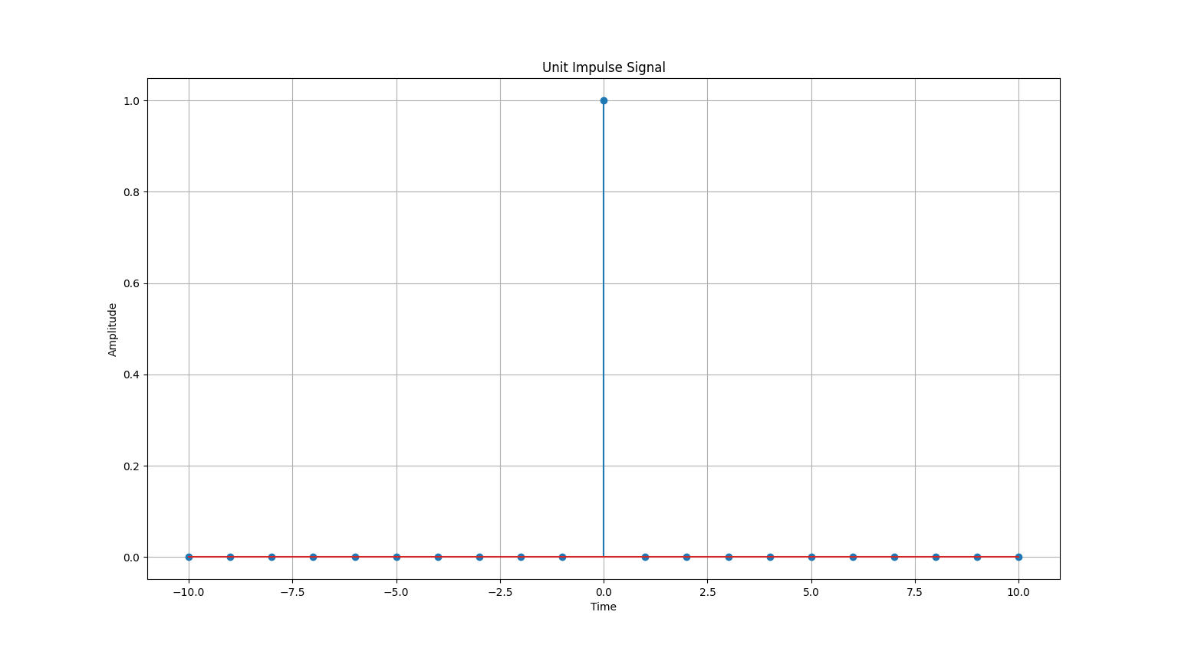

1. Write a Python Programm To Plot Unit Impulse Train.

**Programm:-**

import matplotlib.pyplot as plt

import numpy as np

def simulate_impulse_train(*signal_length*, *period*):

    impulse_train = np.zeros(signal_length)

    for n in range(signal_length):

        if n % period == 0:

            impulse_train[n] = 1

    return impulse_train

*# Define the parameters for the impulse train*

signal_length = 100  *# Length of the impulse train*

period = 10  *# Period of the impulse train*

*# Simulate the impulse train*

impulse_train = simulate_impulse_train(signal_length, period)

*# Plot and display the impulse train*

plt.stem(impulse_train)

plt.title('Impulse Train')

plt.xlabel('Sample')

plt.ylabel('Amplitude')

plt.show()

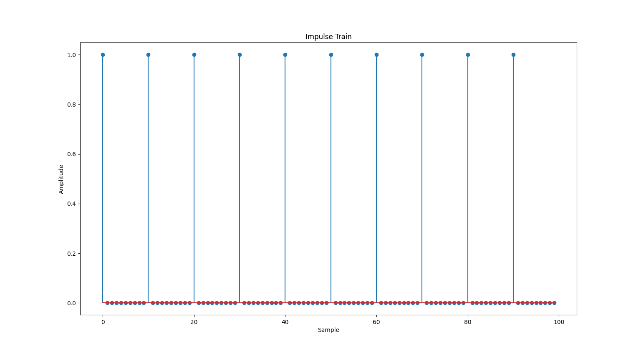**Output:-**

1. Write a Python Program to Simulate Continuous and Discrete Unit Step Signals.

**Programm:-**

import matplotlib.pyplot as plt

import numpy as np

def simulate_continuous_unit_step(*time*):

    unit_step = np.zeros_like(time)

    unit_step[time >= 0] = 1

    return unit_step

def simulate_discrete_unit_step(*num_samples*):

    unit_step = np.zeros(num_samples)

    unit_step[num_samples // 2:] = 1

    return unit_step

*# Define the time range for the continuous unit step signal*

time = np.linspace(-5, 5, 1000)  *# Time range from -5 to 5*

*# Simulate the continuous unit step signal*

continuous_unit_step = simulate_continuous_unit_step(time)

*# Define the number of samples for the discrete unit step signal*

num_samples = 20  *# Number of samples*

*# Simulate the discrete unit step signal*

discrete_unit_step = simulate_discrete_unit_step(num_samples)

*# Plot and display the continuous and discrete unit step signals*

plt.figure(*figsize*=(10, 6))

plt.subplot(2, 1, 1)

plt.plot(time, continuous_unit_step)

plt.title('Continuous Unit Step Signal')

plt.xlabel('Time')

plt.ylabel('Amplitude')

plt.subplot(2, 1, 2)

plt.stem(discrete_unit_step)

plt.title('Discrete Unit Step Signal')

plt.xlabel('Sample')

plt.ylabel('Amplitude')

plt.tight_layout()

plt.show()

**Output:-**

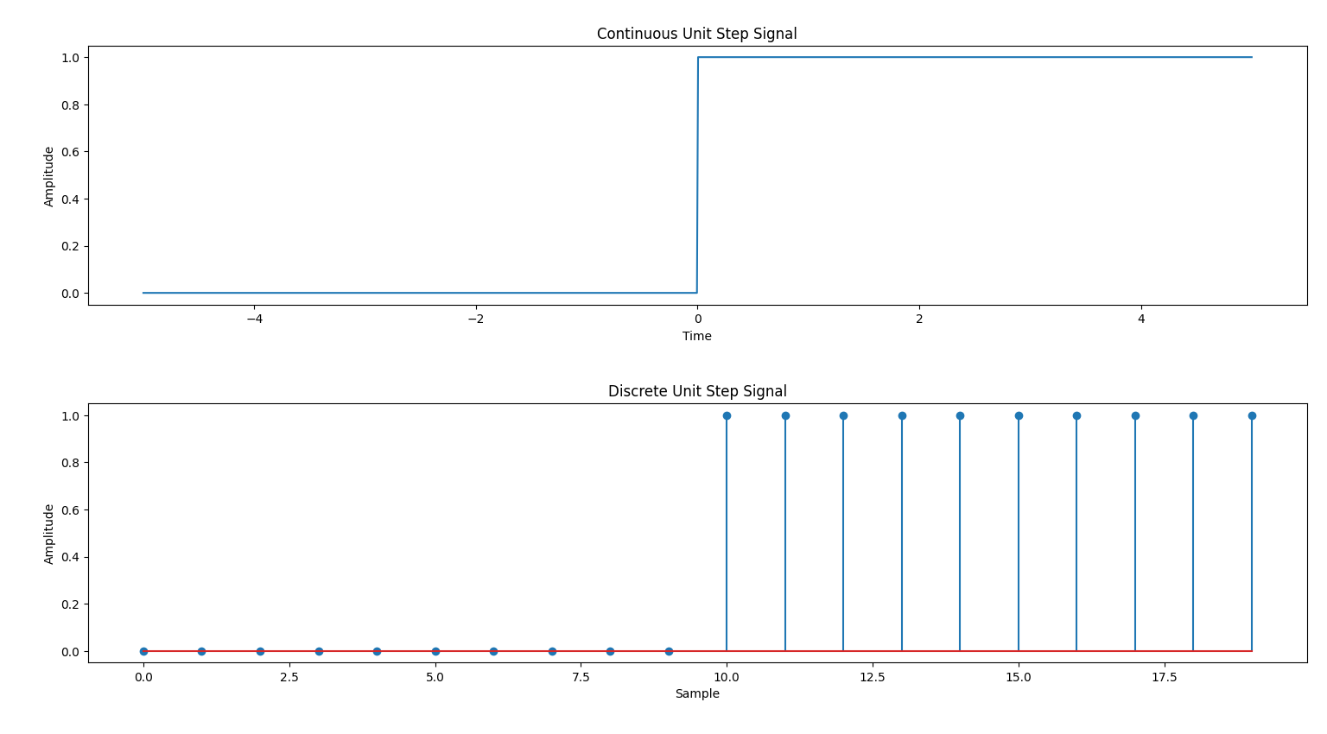

1. Write a Python Program to Simulate Continuous and Discrete Unit Ramp Signals.

**Programm:-**

import matplotlib.pyplot as plt

import numpy as np

def simulate_continuous_ramp(*time*, *slope*):

    ramp = np.zeros_like(time)

    ramp[time >= 0] = slope * time[time >= 0]

    return ramp

def simulate_discrete_ramp(*num_samples*, *slope*):

    ramp = np.zeros(num_samples)

    ramp[num_samples // 2:] = slope * np.arange(num_samples // 2, num_samples)

    return ramp

*# Define the time range for the continuous ramp signal*

time = np.linspace(-5, 5, 1000)  *# Time range from -5 to 5*

*# Define the number of samples and slope for the discrete ramp signal*

num_samples = 20  *# Number of samples*

slope = 2  *# Slope of the ramp*

*# Simulate the continuous ramp signal*

continuous_ramp = simulate_continuous_ramp(time, slope)

*# Simulate the discrete ramp signal*

discrete_ramp = simulate_discrete_ramp(num_samples, slope)

*# Plot and display the continuous and discrete ramp signals*

plt.figure(*figsize*=(10, 6))

plt.subplot(2, 1, 1)

plt.plot(time, continuous_ramp)

plt.title('Continuous Ramp Signal')

plt.xlabel('Time')

plt.ylabel('Amplitude')

plt.subplot(2, 1, 2)

plt.stem(discrete_ramp)

plt.title('Discrete Ramp Signal')

plt.xlabel('Sample')

plt.ylabel('Amplitude')

plt.tight_layout()

plt.show()

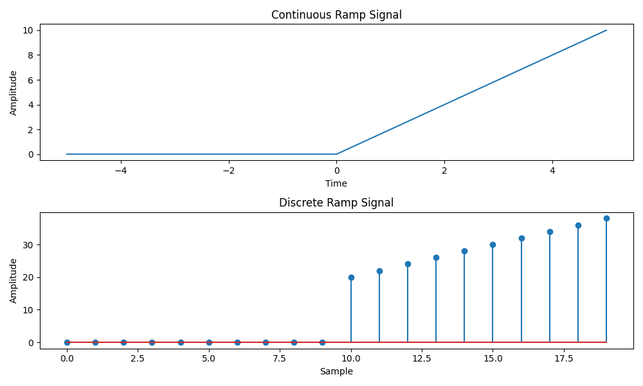**Output:-**

1. Write a Python Program to Simulate Continuous and Discrete Exponential Signals.

**Programm:-**

import matplotlib.pyplot as plt

import numpy as np

def simulate_continuous_exponential(*time*, *amplitude*, *coefficient*):

    exponential_signal = amplitude * np.exp(coefficient * time)

    return exponential_signal

def simulate_discrete_exponential(*num_samples*, *amplitude*, *coefficient*):

    exponential_signal = amplitude * \

        np.exp(coefficient * np.arange(num_samples))

    return exponential_signal

*# Define the time range for the continuous exponential signal*

time = np.linspace(0, 5, 1000)  *# Time range from 0 to 5*

*# Define the number of samples, initial amplitude, and coefficient for the*

*# discrete exponential signal*

num_samples = 20  *# Number of samples*

amplitude = 2  *# Initial amplitude*

coefficient = -0.5  *# Exponential coefficient*

*# Simulate the continuous exponential signal*

continuous_exponential = simulate_continuous_exponential(

    time, amplitude, coefficient)

*# Simulate the discrete exponential signal*

discrete_exponential = simulate_discrete_exponential(

    num_samples, amplitude, coefficient)

*# Plot and display the continuous and discrete exponential signals*

plt.figure(*figsize*=(10, 6))

plt.subplot(2, 1, 1)

plt.plot(time, continuous_exponential)

plt.title('Continuous Exponential Signal')

plt.xlabel('Time')

plt.ylabel('Amplitude')

plt.subplot(2, 1, 2)

plt.stem(discrete_exponential)

plt.title('Discrete Exponential Signal')

plt.xlabel('Sample')

plt.ylabel('Amplitude')

plt.tight_layout()

plt.show()

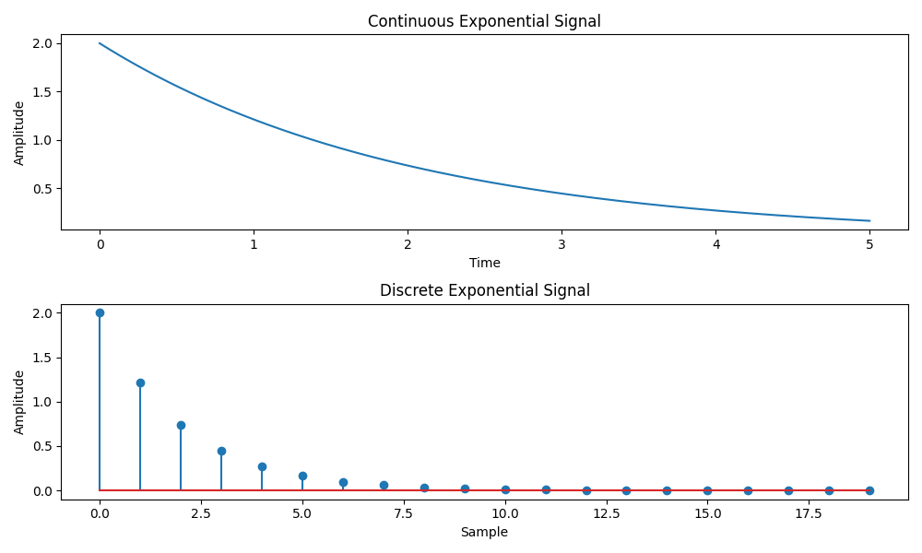**Output:-**

1. Write a Python Program to Simulate Continuous and Discrete Parabolic Signals.

**Programm:-**

import matplotlib.pyplot as plt

import numpy as np

def simulate_continuous_parabolic(*time*, *coefficients*):

    parabolic_signal = np.polyval(coefficients, time)

    return parabolic_signal

def simulate_discrete_parabolic(*num_samples*, *coefficients*):

    parabolic_signal = np.polyval(coefficients, np.arange(num_samples))

    return parabolic_signal

*# Define the time range for the continuous parabolic signal*

time = np.linspace(-5, 5, 1000)  *# Time range from -5 to 5*

*# Define the number of samples and coefficients for the discrete parabolic*

*# signal*

num_samples = 20  *# Number of samples*

coefficients = [1, 2, 1]  *# Coefficients of the parabolic signal*

*# Simulate the continuous parabolic signal*

continuous_parabolic = simulate_continuous_parabolic(time, coefficients)

*# Simulate the discrete parabolic signal*

discrete_parabolic = simulate_discrete_parabolic(num_samples, coefficients)

*# Plot and display the continuous and discrete parabolic signals*

plt.figure(*figsize*=(10, 6))

plt.subplot(2, 1, 1)

plt.plot(time, continuous_parabolic)

plt.title('Continuous Parabolic Signal')

plt.xlabel('Time')

plt.ylabel('Amplitude')

plt.subplot(2, 1, 2)

plt.stem(discrete_parabolic)

plt.title('Discrete Parabolic Signal')

plt.xlabel('Sample')

plt.ylabel('Amplitude')

plt.tight_layout()

plt.show()

**Output:-**

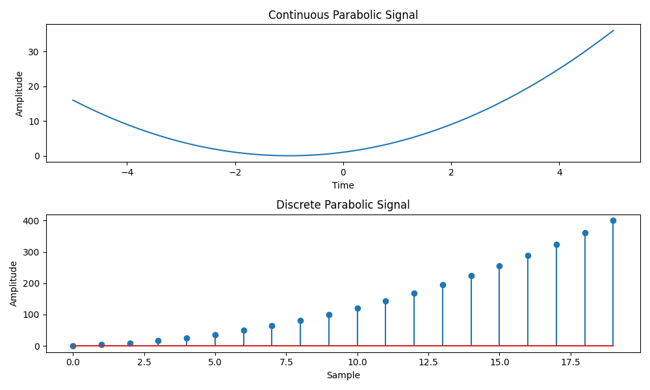

1. Write a Python Program to Simulate Continuous and Discrete Sine Wave Signals.

**Programm:-**

import matplotlib.pyplot as plt

import numpy as np

def simulate_continuous_sine_wave(*time*, *amplitude*, *frequency*, *phase*):

    sine_wave = amplitude * np.sin(2 * np.pi * frequency * time + phase)

    return sine_wave

def simulate_discrete_sine_wave(*num_samples*, *sampling_frequency*, *amplitude*,

*frequency*, *phase*):

    time = np.arange(num_samples) / sampling_frequency

    sine_wave = amplitude * np.sin(2 * np.pi * frequency * time + phase)

    return sine_wave

*# Define the time range for the continuous sine wave signal*

time = np.linspace(0, 1, 1000)  *# Time range from 0 to 1 second*

*# Define the number of samples, sampling frequency, and parameters for the*

*# discrete sine wave signal*

num_samples = 100  *# Number of samples*

sampling_frequency = 10  *# Sampling frequency in Hz*

amplitude = 1  *# Amplitude of the sine wave*

frequency = 2  *# Frequency of the sine wave in Hz*

phase = 0  *# Phase angle of the sine wave in radians*

*# Simulate the continuous sine wave signal*

continuous_sine_wave = simulate_continuous_sine_wave(

    time, amplitude, frequency, phase)

*# Simulate the discrete sine wave signal*

discrete_sine_wave = simulate_discrete_sine_wave(

    num_samples, sampling_frequency, amplitude, frequency, phase)

*# Plot and display the continuous and discrete sine wave signals*

plt.figure(*figsize*=(10, 6))

plt.subplot(2, 1, 1)

plt.plot(time, continuous_sine_wave)

plt.title('Continuous Sine Wave Signal')

plt.xlabel('Time (s)')

plt.ylabel('Amplitude')

plt.subplot(2, 1, 2)

plt.stem(discrete_sine_wave)

plt.title('Discrete Sine Wave Signal')

plt.xlabel('Sample')

plt.ylabel('Amplitude')

plt.tight_layout()

plt.show()

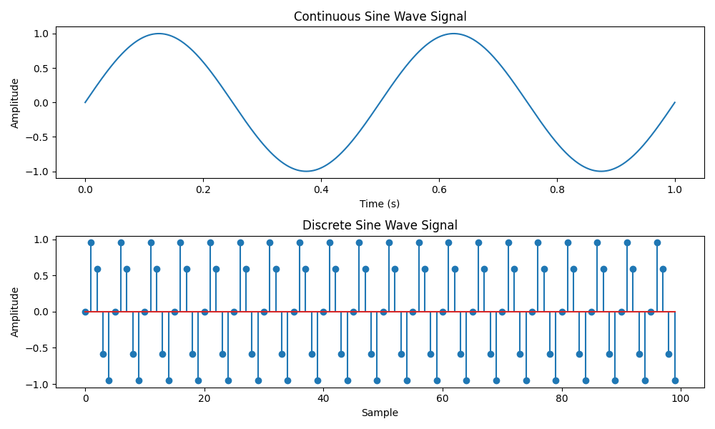**Output:-**

1. Write a Python Program to Simulate y(t) = u(t) + u(t-1) + 3u(t+5).

**Programm:-**

import matplotlib.pyplot as plt

import numpy as np

def simulate_function(*time*):

    y = np.zeros_like(time)

    y[time >= 0] = 1

    y[time >= 1] += 1

    y[time >= -5] += 3

    return y

*# Define the time range*

time = np.linspace(-10, 10, 1000)

*# Simulate the function*

function_values = simulate_function(time)

*# Plot and display the function*

plt.plot(time, function_values)

plt.title('Function y(t) = u(t) + u(t-1) + 3*u(t+5)')

plt.xlabel('Time')

plt.ylabel('Amplitude')

plt.ylim([-0.5, 5.5])

plt.grid(True)

plt.show()

**Output:-**

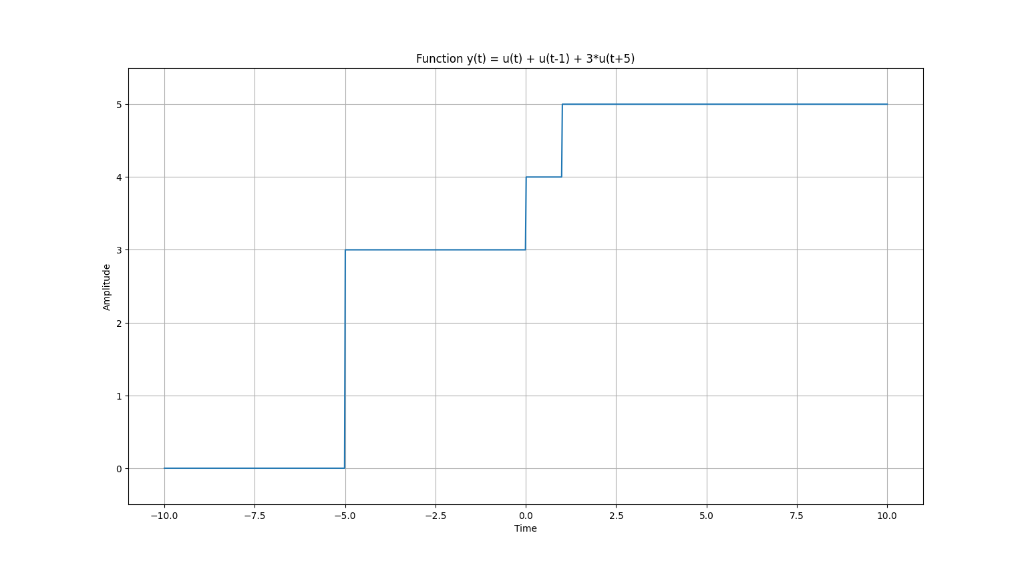

1. Write a Python Program to Simulate y(t) = Delta(t) + Delta(t-1) + 3*Delta(t+5).

**Programm:-**

import matplotlib.pyplot as plt

import numpy as np

def simulate_function(*time*):

    y = np.zeros_like(time)

    y[time == 0] = 1

    y[time == 1] += 1

    y[time == -5] += 3

    return y

*# Define the time range*

time = np.arange(-10, 11)

*# Simulate the function*

function_values = simulate_function(time)

*# Plot and display the function*

plt.stem(time, function_values)

plt.title('Function y(t) = Delta(t) + delta(t-1) + 3*delta(t+5)')

plt.xlabel('Time')

plt.ylabel('Amplitude')

plt.ylim([-0.5, 4.5])

plt.grid(True)

plt.show()

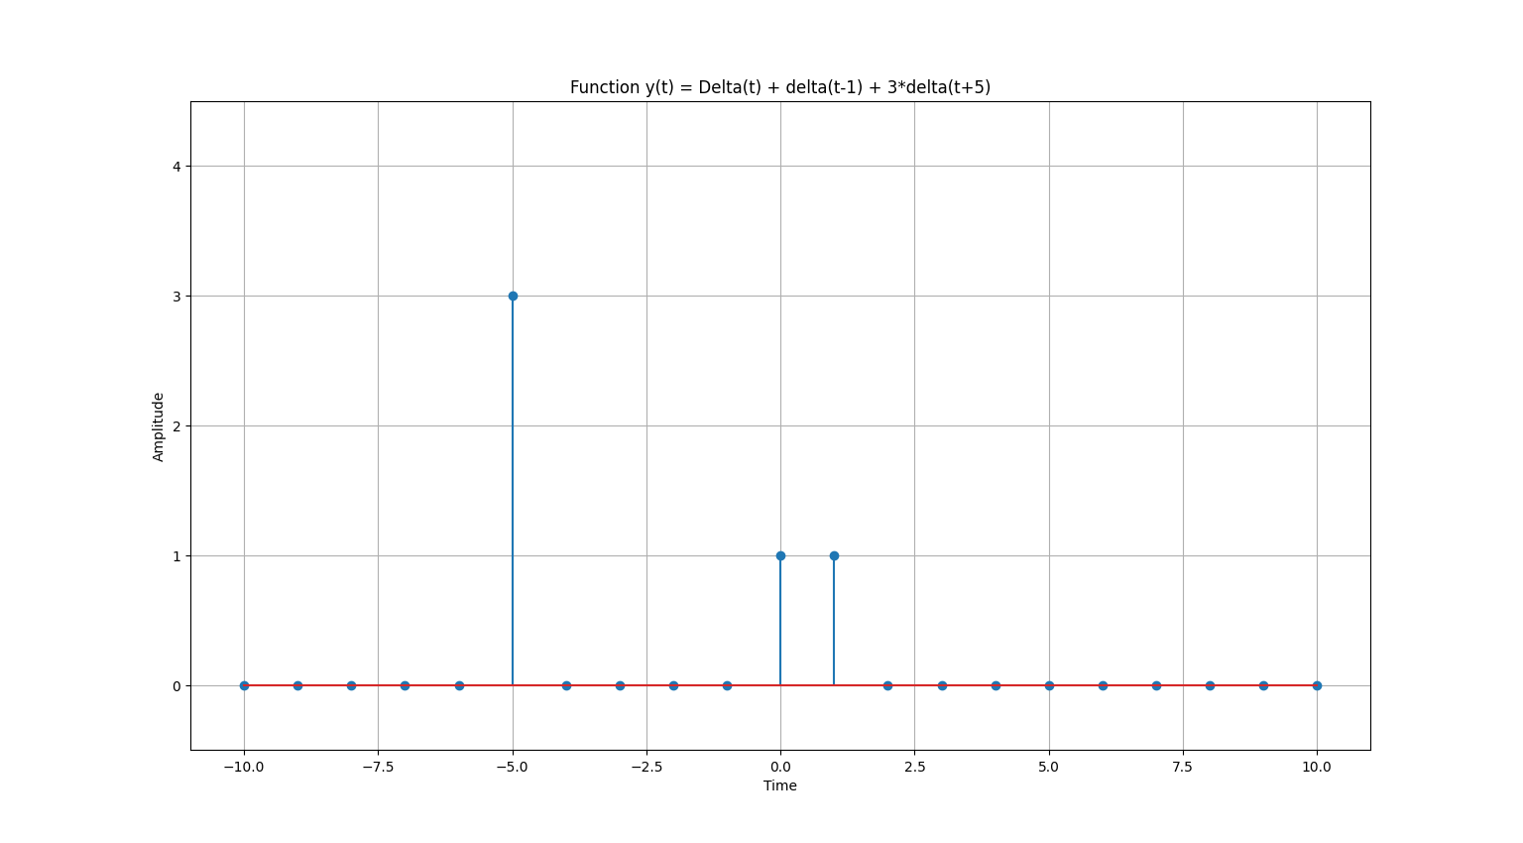**Output:-**

* **Exercise**.

1. Write a Python Program to Simulate y(t) = Delta(t).

**Programm:-**

import matplotlib.pyplot as plt

import numpy as np

def unit_impulse(*length*, *position*):

    signal = np.zeros(length)

    signal[position] = 1

    return signal

*# Parameters*

start = -10  *# Start value of the x-axis range*

stop = 10  *# Stop value of the x-axis range*

step = 1  *# Step size*

*# Generate x-axis values*

x = np.arange(start, stop+step, step)

*# Generate unit impulse signal*

impulse_signal = unit_impulse(len(x), abs(start)//step)

*# Plot the signal*

plt.stem(x, impulse_signal)

plt.xlabel('Time')

plt.ylabel('Amplitude')

plt.title('Unit Impulse Signal')

plt.grid(True)

plt.show()

**Output:-**

1. Write a Python Program to Simulate y(t) = 3 * Delta(n) + 5 * Delta(-n-5) + 8 * Delta(n-7)

**Programm:-**

import matplotlib.pyplot as plt

import numpy as np

def simulate_function(*time*):

    y = np.zeros_like(time)

    y[time == 0] = 3

    y[time == 5] += 5

    y[time == 7] += 8

    return y

*# Define the time range*

time = np.arange(-10, 11)

*# Simulate the function*

function_values = simulate_function(time)

*# Plot and display the function*

plt.stem(time, function_values)

plt.title('Function y(t) = 3 * delta(n) + 5 * delta(-n-5) + 8 * delta(n-7)')

plt.xlabel('Time')

plt.ylabel('Amplitude')

plt.ylim([0, 10])

plt.grid(True)

plt.show()

**Output:-**

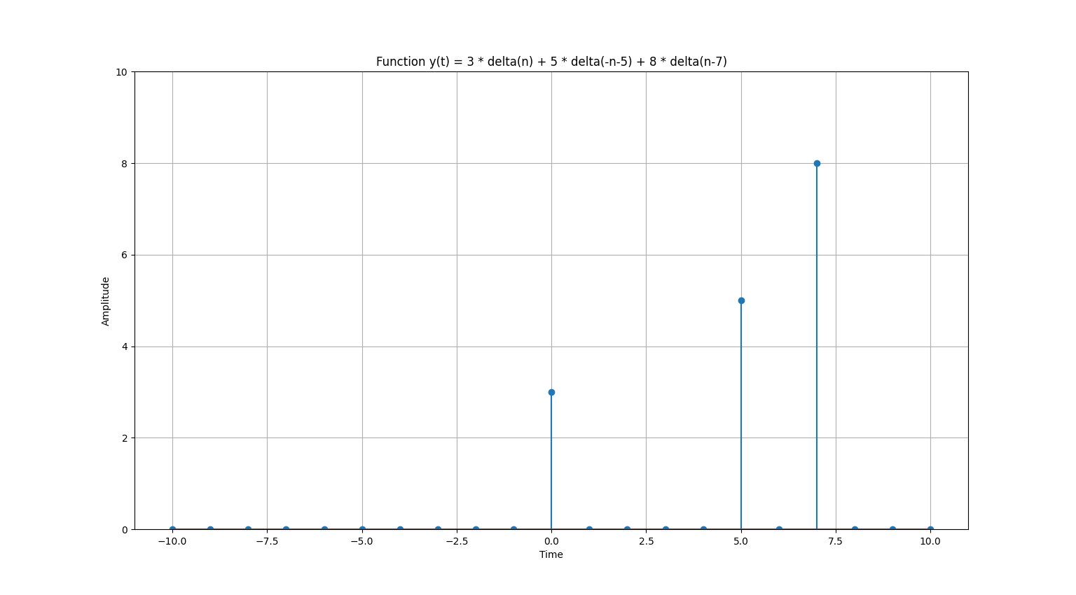

1. Write a Python Program to Simulate y(n) = u(n)

**Programm:-**

import matplotlib.pyplot as plt

import numpy as np

def simulate_discrete_unit_step(*num_samples*):

    unit_step = np.zeros(num_samples)

    unit_step[num_samples // 2:] = 1

    return unit_step

*# Define the number of samples for the discrete unit step signal*

num_samples = 20  *# Number of samples*

*# Simulate the discrete unit step signal*

discrete_unit_step = simulate_discrete_unit_step(num_samples)

*# Plot and display the discrete unit step signal*

plt.figure(*figsize*=(10, 6))

plt.stem(range(-num_samples//2, num_samples//2), discrete_unit_step)

plt.title('Discrete Unit Step Function u(n)')

plt.xlabel('Sample')

plt.ylabel('Amplitude')

plt.ylim([-2, 2])

plt.grid(True)

plt.tight_layout()

plt.show()

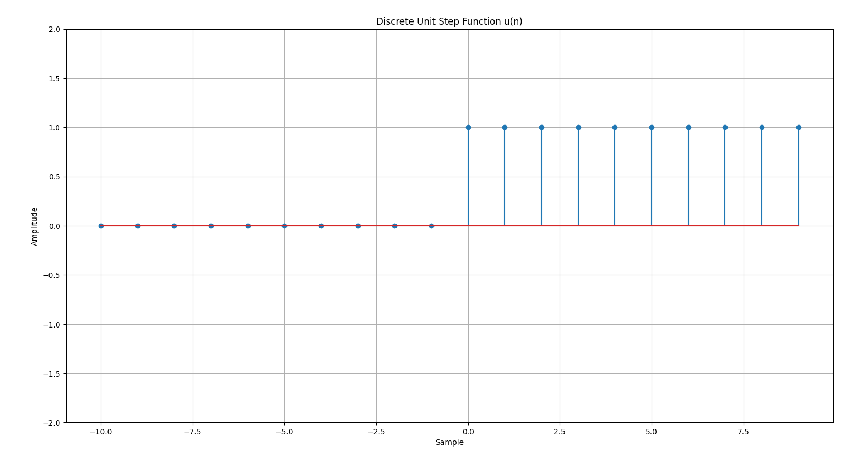**Output:-**

1. Write a Python Program to Simulate y(n) =  u(n-7)

**Programm:-**

import matplotlib.pyplot as plt

import numpy as np

def simulate_discrete_unit_step(*num_samples*, *delay*):

    unit_step = np.zeros(num_samples)

    unit_step[delay:] = 1

    return unit_step

*# Define the number of samples for the discrete unit step signal*

num_samples = 20  *# Number of samples*

delay = 7  *# Delay by 7 samples*

*# Simulate the discrete unit step signal*

discrete_unit_step = simulate_discrete_unit_step(num_samples, delay)

*# Plot and display the discrete unit step signal*

plt.figure(*figsize*=(10, 6))

plt.stem(range(num_samples), discrete_unit_step)

plt.title('y(n) = u(n-7)')

plt.xlabel('Sample')

plt.ylabel('Amplitude')

plt.grid(True)

plt.tight_layout()

plt.show()

**Output:-**

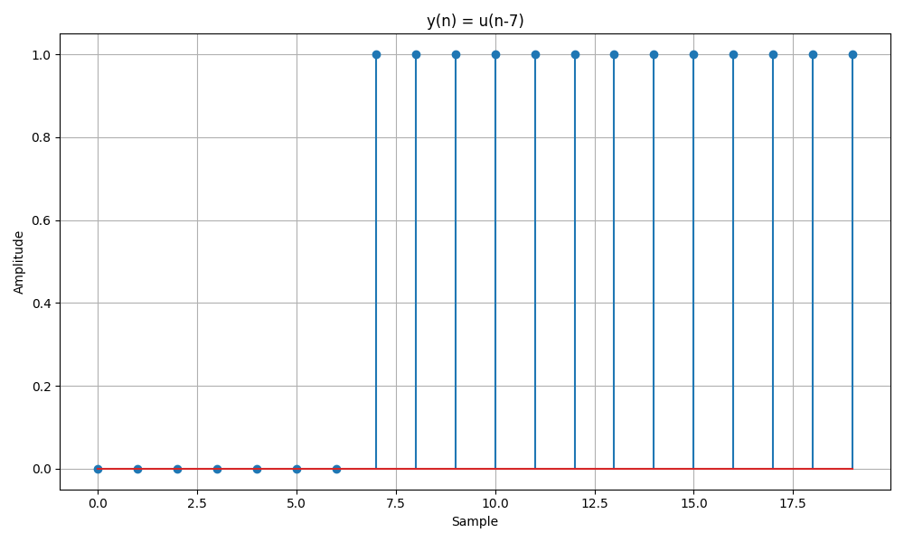

1. Write a Python Program to Simulate y(n) = u(n) + u(n-3) + 6 * u(n-2) + 8 * (-n-1)

**Programm:-**

import matplotlib.pyplot as plt

import numpy as np

def simulate_function(*time*):

    y = np.zeros_like(time)

    y[time >= 0] = 1  *# u(t)*

    y[time >= 3] += 1  *# u(t-3)*

    y[time >= 2] += 6  *# 6*u(n-2)*

    y[time <= 1] += 8  *# 8*u(-n-1)*

    return y

*# Define the time range*

time = np.arange(-10, 11)

*# Simulate the function*

function_values = simulate_function(time)

*# Plot and display the function*

plt.stem(time, function_values)

plt.title('Function y(t) = u(n) + u(n-3) + 6*u(n-2) + 8*(-n-1)')

plt.xlabel('Time')

plt.ylabel('Amplitude')

plt.ylim([-1, 10])

plt.grid(True)

plt.show()

**Output:-**

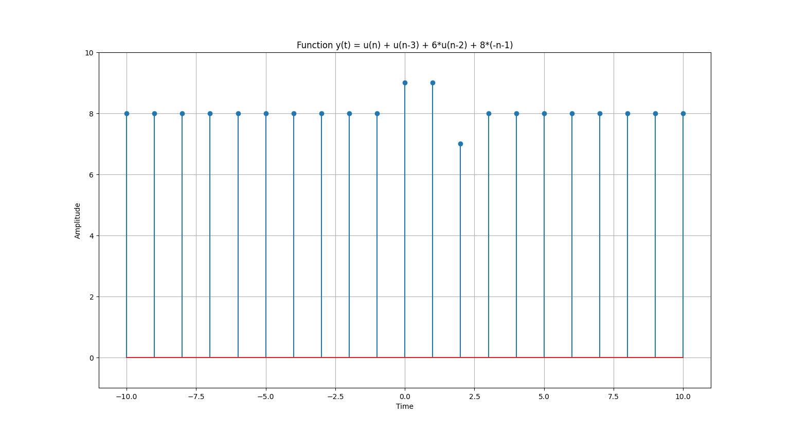

1. Write a Python Program to Simulate y(t) = u(t) + u(t-1) + 3 * u(t+5)

**Programm:-**

import matplotlib.pyplot as plt

import numpy as np

def simulate_function(*time*):

    y = np.zeros_like(time)

    y[time >= 0] = 1

    y[time >= 1] += 1

    y[time >= -5] += 3

    return y

*# Define the time range*

time = np.linspace(-10, 10, 1000)

*# Simulate the function*

function_values = simulate_function(time)

*# Plot and display the function*

plt.plot(time, function_values)

plt.title('Function y(t) = u(t) + u(t-1) + 3*u(t+5)')

plt.xlabel('Time')

plt.ylabel('Amplitude')

plt.ylim([-0.5, 5.5])

plt.grid(True)

plt.show()

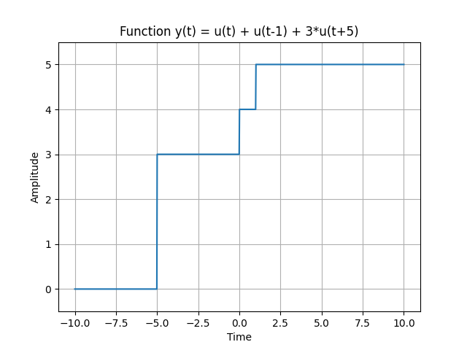**Output:-**

**Conclusion:-**